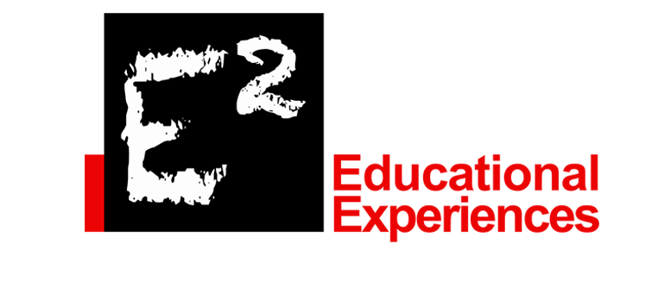FAQ
What is E2 Educational Experiences?
E2 has developed a unique concept that caters to homeschool teachers as well as Health Science teachers in the public and private schools. Medical Science 101 consist of 8 different modules of information for basic health care skills. E2 also has workshops and camps designed for students. Another outstanding feature is our affiliation with HOSA, the student organization that provides leadership, competition, and volunteer opportunities.
How long does it take for my child to complete the full course? Module?
The complete Medical Science 101 consist of 8 modules that can take a full year to complete. Each module last between 2-4 weeks.
What is the price for the book? Modules? Are there additional fees involved?
We are excited to be switching to electronic modules to reduce waste. We have some workbooks left for a closeout sale price of $30 each with free shipping in the continental United States. The online complete workbook is one sale for $30. The modules range in price from $20 for HOSA to $30.00 on this website. We also have a OSHA and HIPAA certification. There is a small additional fee to be certified by an outside company to become certified in either. We find this helps with a students’ employability, resume, and application to college.

Why are the prices higher in TeachersPayTeachers?
TeachersPayTeachers is a wonderful network to provide lessons and activities for teachers, however, TeachersPayTeachers takes a significant profit from the proceeds.
What is included in each module?
Each module has lessons, activities, competency check off sheets for activities, vocabulary, quizzes, medical terminology in most of the module, and a test.
What topics are covered? Topics are specific for each module which include:
Medical Science 101 Medical Science 102
Safety Practices Adv. First Aid: Fractures, Sprains, &
Infection Control Strains with Skeletal System
Chain of Infection Adv. First Aid: Burns & Integumetary
Health Care Delivery System
Basic Medical Technical Skills Adv. First Aid: Infectious Diseases with
CPR and First Aid Immune & Lymphatic Systems
Ethical, Legal, & Moral Responsibilities Coming Soon:
Careers in Health Care Lab Science & Circulatory System
Nutrition with Digestive and Excretory
Systems
Physical & Occupational Therapy &
Muscular System
Complimentary Medicine & Nervous Sys
Respiratory Therapy and Respiratory Sys
Fractures and Skeletal System
The Reproductive System
Please note the order of the forthcoming Medical Science 102 is not the sequence of introduction.
How is my child/student assessed?
Our program is student based and student paced modules that allow the student to go to a pace that better suits their authentic learning and comprehension. Parents and teachers can assess the progress with grade sheets and a comprehensive grade report (portfolio) when the student completes the entire workbook.
How are grades issued? Each state is different.
Please check with you state superintendent or career technology director for more information. This curriculum is equivalent to a full one- year class.

